# Master Project – Design and Implementation of Cattle Tracking Prototype System

**Student:** Yunwei Jiang **Email:** [yjiang8@albany.edu](mailto:yjiang8@albany.edu) **Instructor:** Prof. Mariya Zheleva

**Session:** 2018 Summer

## 1 Project instruction

This cattle tracking prototype system is wireless network system combined with different wireless protocols to track and estimate the density of cattle in farm, collect their location and exchanged data to build up their social graph. This system will use short range wireless protocol BlueTooth to exchange cattle id, and long range protocol LoRa to transfer the collected data to cloud server. Then the collected data will be used for further research of cattle’s individual and herd behavior.

### 1.1 Project Background

This cattle tracking system is a part of FarmNet project of precision rotational grazing (PRG). PRG involves tracking of moving objects (grazing animals) and state of entities (paddocks), based on multiple sensing modalities, dealing with uncertain, delayed and sparse measurements and offers rich opportunities for optimization, analytics and smart connectivity solutions. Rotational grazing involves subdividing a pasture into paddocks and scheduling grazing for different herds of animals in paddocks, so as to maximize the production of grass and legumes and thus the dairy and meat output of the farming operation within limited pasture land.

The sensing modalities FarmNET will employ include (i) GPS, motion and sound sensors for a subsample of cattle allowing us to track the herd’s temporal trajectory, activity (graze/not graze) and health; (ii) low-cost and low-energy Bluetooth beacons for the same subsample to estimate density based on distance to GPS cattle; (iii) AUV-acquired images to estimate and track the grass growth; and (iv) environmental parameters including precipitation and temperature.

### 1.2 System Structure

There are two kinds of structure for the project. We use the second structure to build up the system.

I also build up a GitHub repository to manage the source code and documents. The link below:

<https://github.com/jiangyunwei2015/2018SummerProject_FarmNet>

**Note: For the second structure there are also two solutions: 1) BLE+LoRaWAN Gateway+TTN cloud broker(Chapter 5.4.1) and 2) BLE+LoRa gateway + AdafruitIO cloud broker(Chapter 5.6.1).**

The running code for the system is:

* For BLE+LoRa gateway + AdafruitIO, the source code folders are:

1) For LoRa nano-gateway: Projects/LoRa/LoRaMAC/LoRaMAC_Gateway

2) For LoRa Node & BLE client node devices: Projects/LoRa/LoRaMAC/LoRaMAC_Node2

3) For BLE server device: Projects/Bluetooth/BluetoothNode1

* For BLE+LoRaWAN Gateway+TTN, the source code folders are:

1) For LoRaWAN nano-gateway: Projects/LoRa/LoRaWAN

2) For LoRaWAN Node & BLE client node devices: Projects/ProtypeNodePrj

3) For BLE server device: Projects/Bluetooth/BluetoothNode1

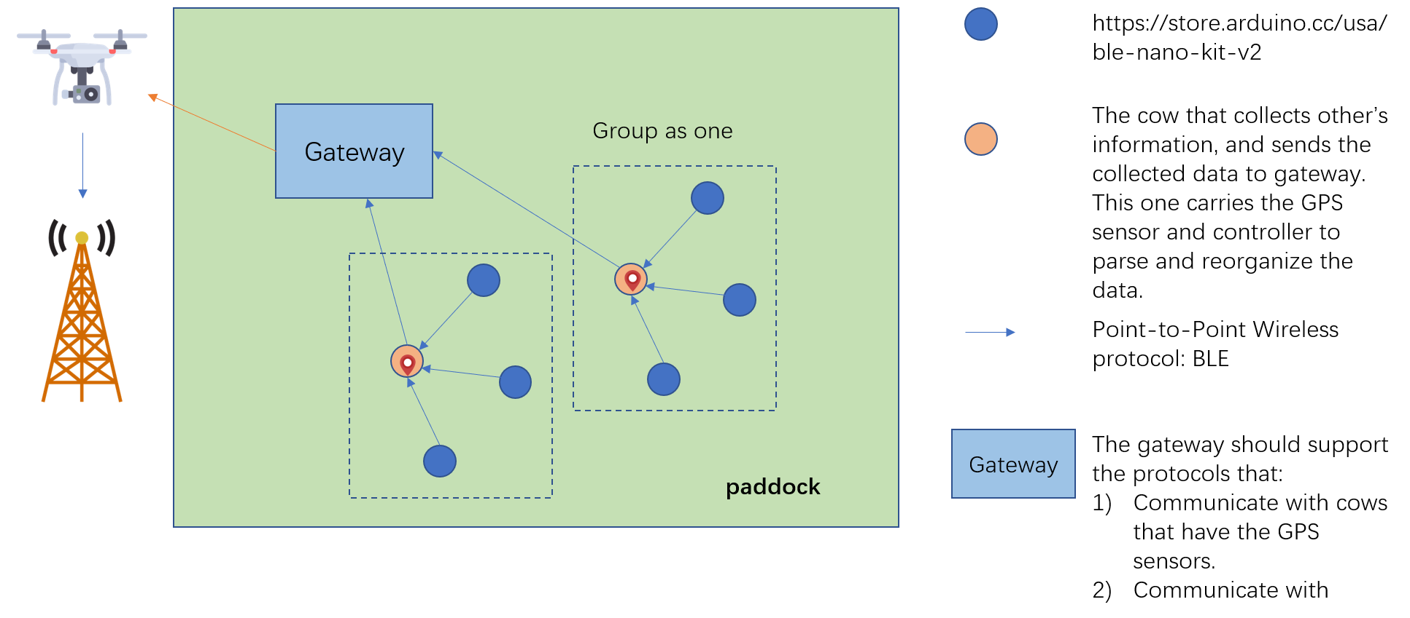

Fig1 Cattle Tracking architecture 1st version

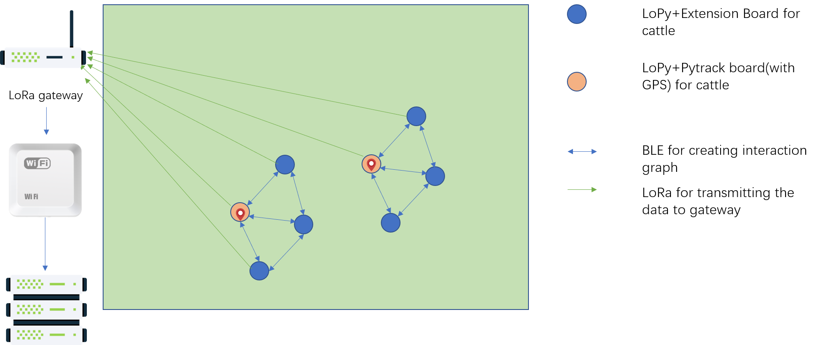

Fig2 Cattle Tracking architecture 2nd version

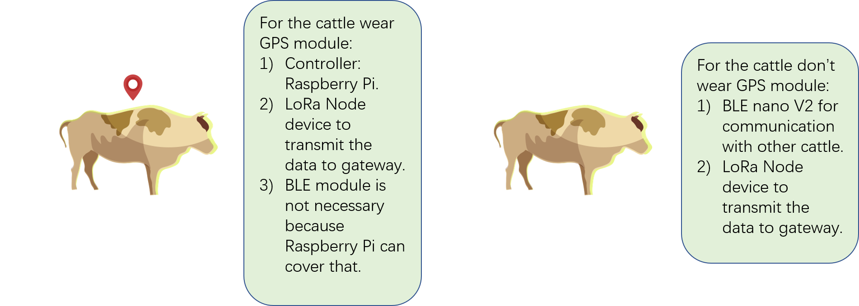

Fig3 Devices worn by cattle version 1

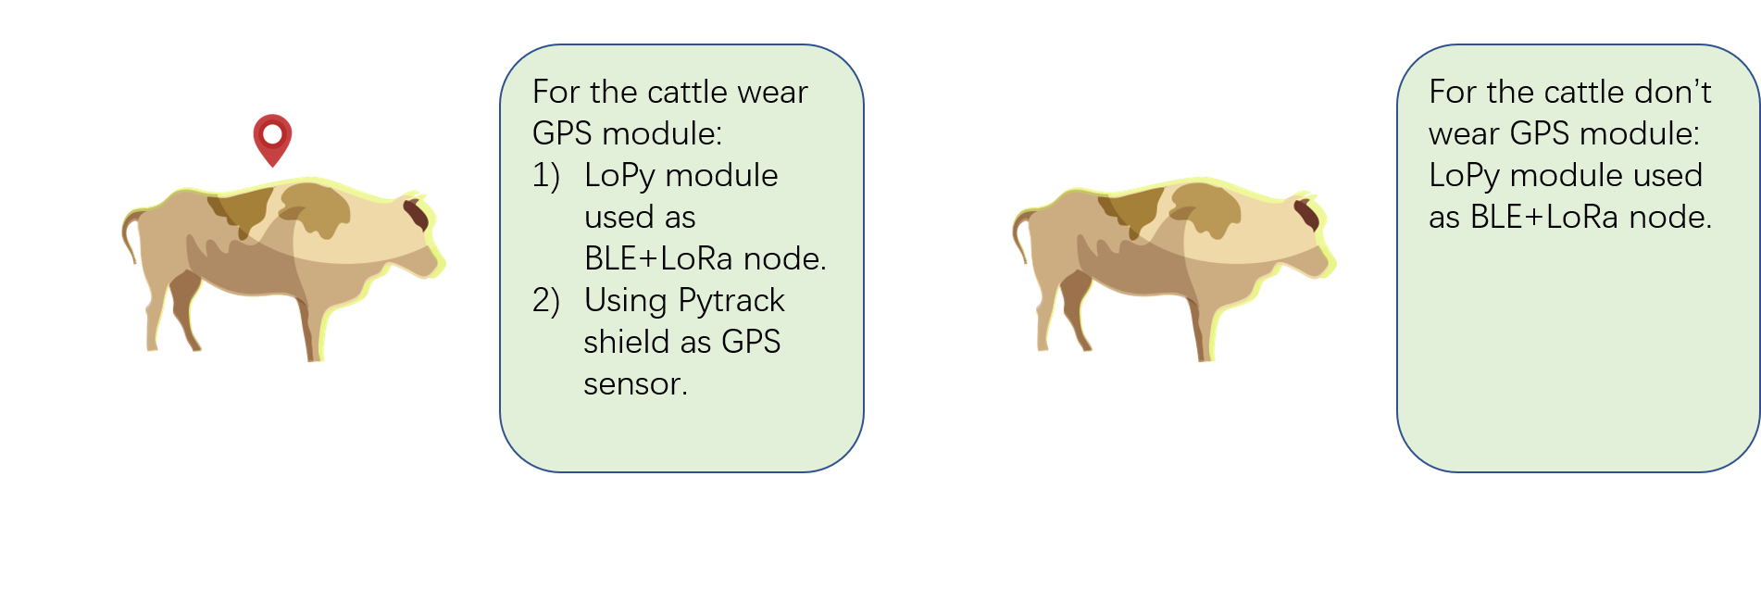

Fig4 Devices worn by cattle version 2

**Note: We use the second structure: using LoPy+Pytrack/Expansion board to trace the cattle, LoPy as LoRa nano-gateway to forward the data to cloud server.**

## 2 Device List

### 2.1 Gateway

Works as a bridge between communication devices worn by cattle and the server.

This is actually a LoRaWAN or LoRa gateway that could catch LoRa packet and forward to cloud server as TTN, Loriot, Adafruit IO, AWS,.etc.

**Right now use LoPy as the single-channel gateway.**

### 2.2 BLE device

Communicate between cattle.

|  |  |  |  |
| --- | --- | --- | --- |
| Device | Parameters | Price | Purchase Link |
| **BLE Nano Kit V2**  **(Including a companion board, DAPLink v1.5 board, which is used to load firmware into BLE Nano 2 from a PC)** | 1) nRF52832 BLE SoC  32-bit ARM® Cortex™-M4F CPU with 512kB flash + 64kB RAM  2.4GHz BLE  Bluetooth5  2) Mynewt OS | $32.95 | Purchase link:  <https://store.arduino.cc/usa/ble-nano-kit-v2> |
| **BLE Nano V2** | BLE SoC development board  BLE  1xUART  2xSPI  1xI2C  On board chip antenna | $17.95 | Purchase link:  <https://store.arduino.cc/usa/ble-nano-v2-with-header-soldered> |

### 2.3 GPS sensor

GPS sensors are worn by a certain number of cattle that collect data from other cattle.

|  |  |  |  |
| --- | --- | --- | --- |
| Device | Parameters | Price | Purchase Link |
| **Adafruit Ultimate Breakout** | Satellites: 22 tracking, 66 searching  Patch Antenna Size: 15mm x 15mm x 4mm  Update rate: 1 to 10 Hz  Position Accuracy: < 3 meters  Warm/cold start: 34 seconds  Built in antenna | $39.95 | <https://www.adafruit.com/product/746> |
| **GPS Antenna** | External Active Antenna - 3-5V 28dB 5 Meter SMA | $14.95 | <https://www.adafruit.com/product/960> |
| **SMA to uFL/u.FL/IPX/IPEX RF Adapter Cable** |  | $3.95 | <https://www.adafruit.com/product/851> |

### 2.4 LoRa device

|  |  |  |  |
| --- | --- | --- | --- |
| Device | Parameters | Price | Purchase Link |
| mDot  Long Range LoRa® Modules | The MultiConnect® mDotTM is a secure, CE/FCC/RCM certified, Arm® MbedTM programmable, low-power RF module that provides long-range, low bit rate M2M data connectivity to sensors, industrial equipment and remote appliances. | $31~32(Based on different spectrum) | Introduction:  https://www.multitech.com/brands/multiconnect-mdot |
| MultiConnect® mDotTM Developer Kit | The MultiConnect® mDot™ Developer Kit allows customers to plug in the MultiConnect mDot module and use it for testing, programming and evaluation. | $69.00 | Introduction:  <https://www.multitech.com/brands/micro-mdot-devkit>  Purchase:  <https://www.semiconductorstore.com/cart/pc/viewPrd.asp?idproduct=50707> |
| Arduino Shield |  |  |  |

**Question:** Which Spectrum? mDot supports 868 or 915 MHz.

### 2.5 Controller

Because the data comes from different sources (GPS, BLE), the controller can reorganize and pack the data, then send to gateway.

|  |  |  |  |
| --- | --- | --- | --- |
| Device | Parameters | Price | Purchase Link |
| BeagleBone Black |  |  |  |
| Arduino uno | CPU:ATmega328P 16MHz  Flash:32KB  RAM:2KB SRAM | $22.00 | https://store.arduino.cc/usa/arduino-uno-rev3 |
| Raspberry Pi | ARM Cortex-A53  Bluetooth 4.2/BLE | $35.00 | https://www.adafruit.com/product/3775?src=raspberrypi |

### 2.6 Purchase list

|  |  |  |
| --- | --- | --- |
| Device | Purpose | Price |
| **BLE Nano Kit V2 X1** |  | 1* $32.95 |
| **BLE Nano V2 X3** |  | 3* $17.95 |
| **GPS sensor X1** |  | 1* $39.95 |
| **GPS Antenna X1** |  | 1* $14.95 |
| **SMA to uFL/u.FL/IPX/IPEX RF Adapter Cable X1** |  | 1* $3.95 |
| **mDot** |  | 1* around $32 |
| **mDot Development Kit** |  | 1* $69 |

### 2.7 Final version device list (2018-06-15)

After searching and comparing for almost two week, now decide to choose LoPy from Pycom as the LoRa node device. LoPy is a BLE+WiFi+LoRa+LoRa nano gateway development board for IoT application.

So now the gateway. To start the work, there are some devices that will used to build up the protype and test:

|  |  |  |
| --- | --- | --- |
| Device | Number | Usage |
| LoPy | 4 | As BLE and LoRa node device, and need to test the performance as a nano gateway. |
| Antenna | 4 | For each LoPy, it needs a external antenna to work normally. |
| Pytrack | 1 | Development shield for LoPy, also contains a GPS receiver. |
| Extension Board 2.0 | 3 | Development shield for LoPy. |
| USB hub | 1 | Power supply for LoPys. |

## 3 Questions

### 3.1 What’s the gateway range?

The size of the farm is 1100 acres. LoRa gateway can cover the farm without problem.

But still need multiple gateways to resolve data collision problem.

### 3.2 Is there any connection between the cows with the GPS sensors?

Yes. The goal is to build up the social graph for each cow.

### 3.3 What’s the data transmittd between BLE devices?

For cows without GPS sensor: device id. The device id will be hard coded in LoPy.

### 3.4 Does all BLE devices store the data?

Probably not. Only transmit the data when comes close to another device.

### 3.5 How often will the data be collected?

### 3.6 Accuracy of the GPS sensor?

Almost all sensor support +/- 3m.

### 3.7 External Power Supply

Battery? Power Bank?

### 3.8 Memory Size

### 3.9 Micro sd card and card reader for flashing the OS?

### 3.10 About the gateway: Buy product or self-integrated?

1 There is a gateway also developed by MultiTech: MultiTech® Conduit™ Gateway + mCard around $440

<https://www.multitech.com/brands/multiconnect-conduit>

And rugged outdoor version MultiConnect® Conduit™ IP67 Base Station.

<https://www.multitech.com/brands/multiconnect-conduit-ip67>

The figure below shows the structure of mDot with MultiConnect Conduit gateway:

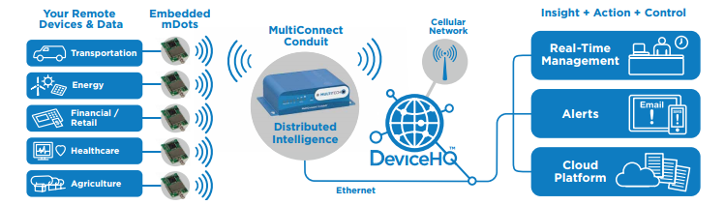

2 Self-integrated

There are some self-integrated gateway solutions.

Still searching.

### 3.11 ~~How to integrate GPS sensor and mDot to Raspberry pi?~~

1) GPS sensor to Raspberry pi

Input: GPS, output: Rasperry pi

<https://learn.adafruit.com/adafruit-ultimate-gps-on-the-raspberry-pi/introduction>

2) mDot to Raspberry pi

Input: Raspberry pi, output:mDot

### 3.12 ~~How to integrate BLE nano V2 to mDot?~~

Using BLE nano V2 as input source, and mDot as the output source. So need to find out if nano V2 can connect to mDot?

Or still need other shield or controller as a bridge?

As the picture shows below:

mDot can accept data from other device by using SPI, UART, I2C.

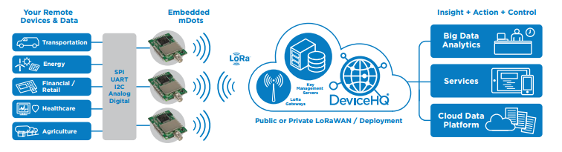

BLE nano V2 supports these:

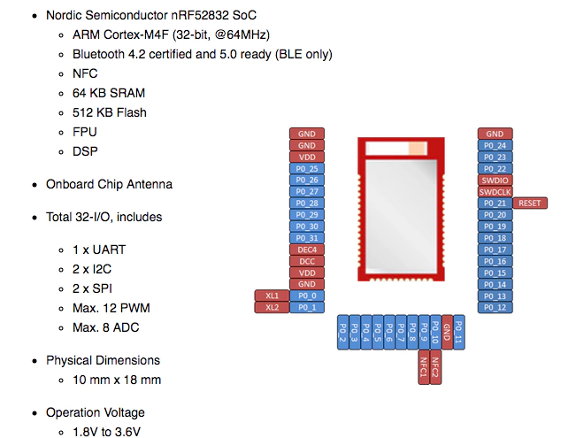

### 3.13 ~~The communication between BLE nano V2 and Raspberry pi~~

Since



### 3.14 How to test the performance of LoPy both as LoRa node and nano gateway?

## 4 Shopping website

### 4.1 Aruino

### <https://www.arduino.cc/>

### 4.2 Sparkfun

### <https://www.sparkfun.com/>

### 4.3 Adafruit

<https://www.adafruit.com/>

## 5 Development Work Progress

The first three weeks is used for project preparation as paper reading, background knowledge learning, information collecting, device selecting.

### 5.1 Summer Week 4: 06-18~06-22

#### 06-22 Start to work on LoPy

Got all the devices today. First, build up the IDE environment and update firmware for LoPy and Pytrack:

##### 5.1.1 Update Firmware of Pytrack

There is a problem, I can’t get any information from the tools as described in the official doc:

<https://docs.pycom.io/chapter/pytrackpysense/installation/firmware.html>

Except the first time when I followed the instruction and tried to connected Pytrack by using **Zadig** and the information shows as the doc shows, but when I click install driver, it failed and for the rest time Zadig can’t recognize Pytrack anymore:

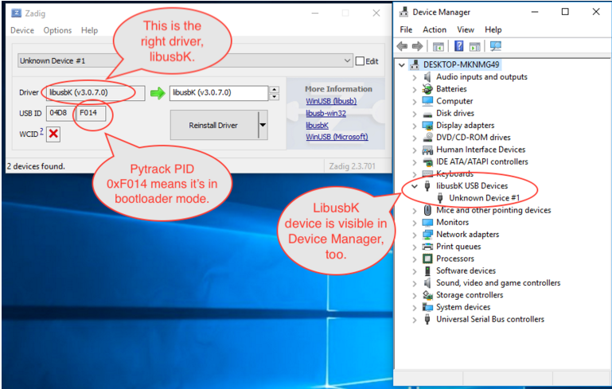

Fig 1 The connection result shown in official doc

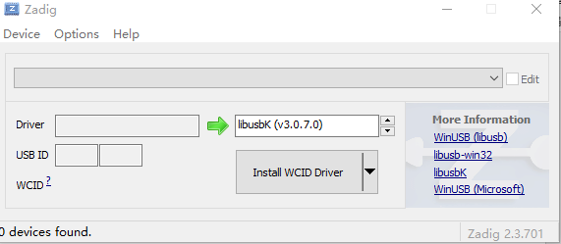

Fig 2

And when using dfu tool to update the firmware, it failed(No DFU capable USB device available).

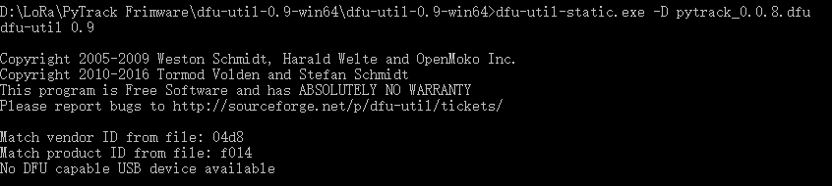

**But! After followed this instruction from forum, I could still update the firmware for Pytrack:**

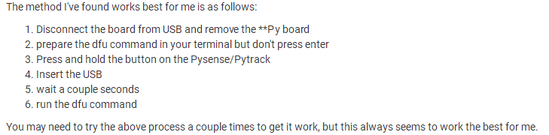

After this input the command in console: **dfu-util-static.exe -D pysense_X.X.X.dfu(change X.X.X to the version of dfu file!)**

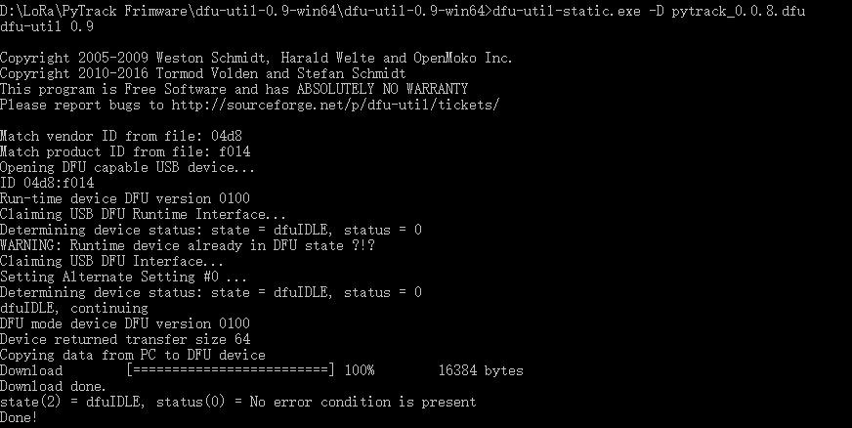

It works!!!

**Need to check this with pycom!**

I guess maybe for Win10 may just automatically installed the

##### 5.1.2 Update firmware for LoPy by Pytrack

Pytrack is easy compared to expansion board 2.0, since it doesn’t need external connection wire:

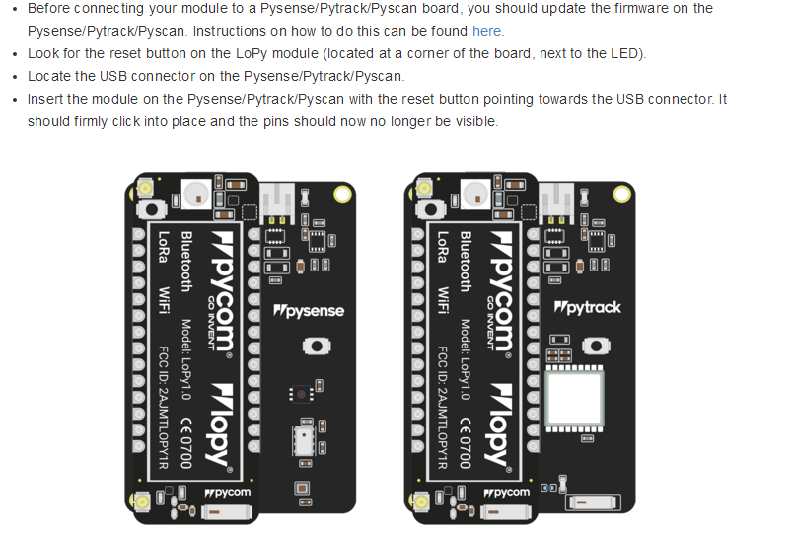

This is from:

https://docs.pycom.io/chapter/gettingstarted/connection/lopy.html#pic

Then use the Pycom upgrade tool to update device firmware:

https://docs.pycom.io/chapter/gettingstarted/installation/firmwaretool.html#second

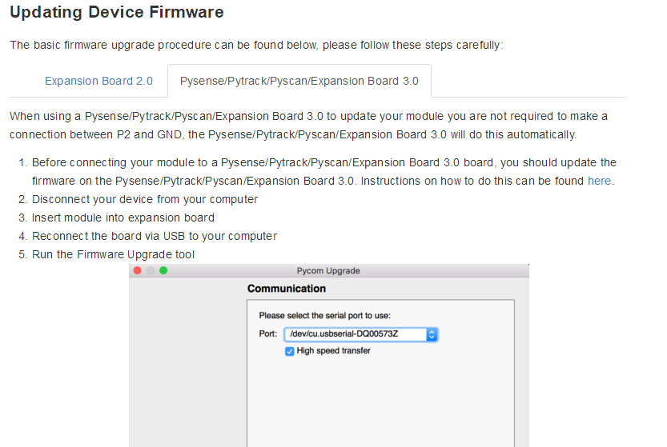

In the Pycom Upgrade Tool:

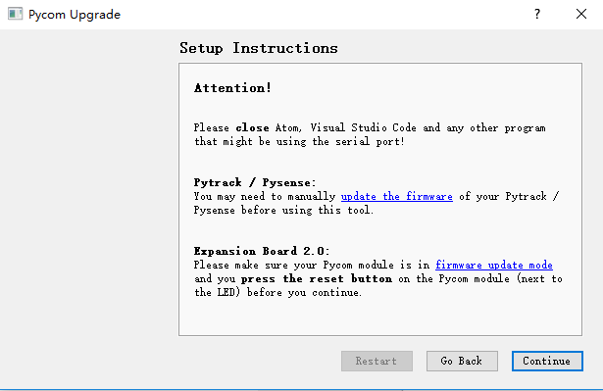

**Note: there are some differences from the official doc!**

##### 5.1.3 Update firmware for LoPy by Expansion Board 2.0

##### 5.1.4 Setup the IDE environment

Just follow the instruction: https://docs.pycom.io/chapter/pymakr/installation/vscode.html

LoPy use the MicroPython as the programming language.

The recommended IDE is: Visual Studio Code(1.24.1) + NodeJS Latest LTS Version (I installed 8.11.3) + Pymakr Plugin for VS code.

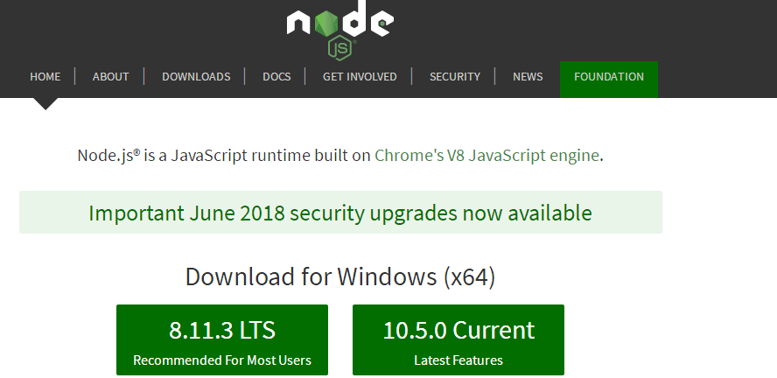

Pymakr is the plugin provided from pycom that could used in vs code.

<https://marketplace.visualstudio.com/items?itemName=pycom.Pymakr>

Just follow the instruction correctly, then will connect LoPy successfully:

**This is connected by serial ports:**

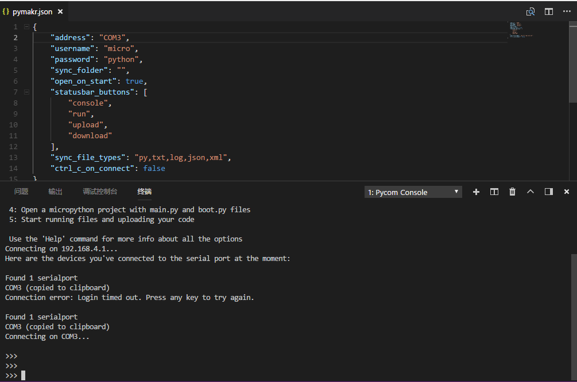

##### 5.1.5 Connect to LoPy by Telnet

##### 5.1.6 Connect to LoPy by FTP

**url**: ftp://192.168.4.1

**username**: micro

**password**: python

##### 5.1.7 First MicroPython example

LoPy has a lot API:

<https://docs.pycom.io/chapter/firmwareapi/>

### 5.2 Summer Week 5: 06-25~06-29

#### 06-25

##### 5.2.1 Update firmware for LoPy by Expansion Board 2.0

Finish firmware update for all LoPy boards today.

About how to insert LoPy to expansion board 2.0:

<https://docs.pycom.io/chapter/gettingstarted/connection/lopy.html>

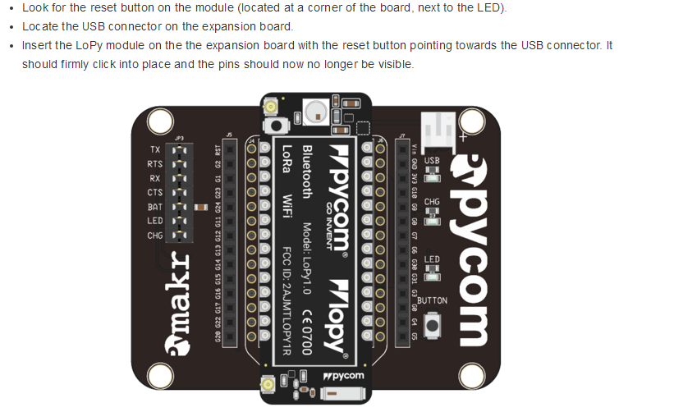

Since don’t need to update the firmware of expansion board 2.0, so just insert Lopy to it. But when update firmware for LoPy, need to use a wire to connect G23 and GND in expansion board.

Follow the link below:

https://docs.pycom.io/chapter/gettingstarted/installation/firmwaretool.html

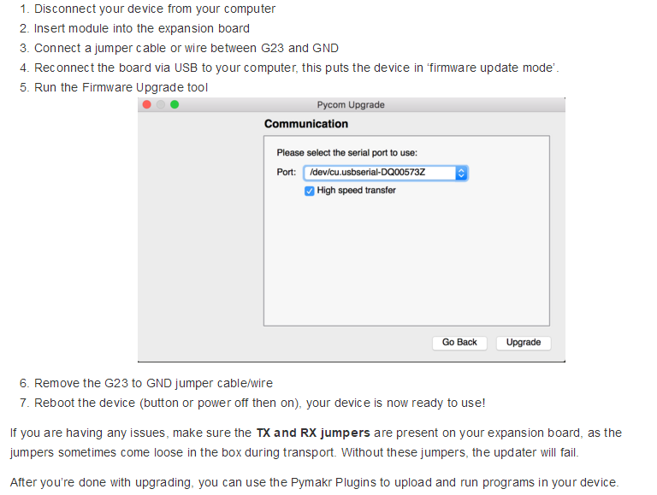

**Attention! When using the pycom upgrade tool with expansion board 2.0, when this dialog shows, press the reset button before continue!**

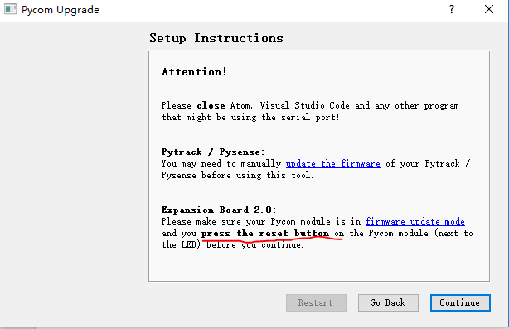

##### 5.2.2 LoRa Communication between two LoPys

##### 5.2.3 BLE

##### 5.2.4 GPS example of Pytrack

#### 06-27

Finish Bluetooth communication between two LoPys tests. One as server(which sending the ID all time) and the other one as client(receiving ID and disconnect after get ID).

TO DO list:

1) Still need to know the background knowledge of BLE,GATT

2) There are some other tests need to do:

One server to multiple clients

One client to multiple servers

Multiple servers to multiple clients

#### 06-28

##### 1 I tried to figure out how does BLE work in LoPy:

1) As a server/Central:

Set up an advertisement and send it indefinitely

Add callback function to check the status

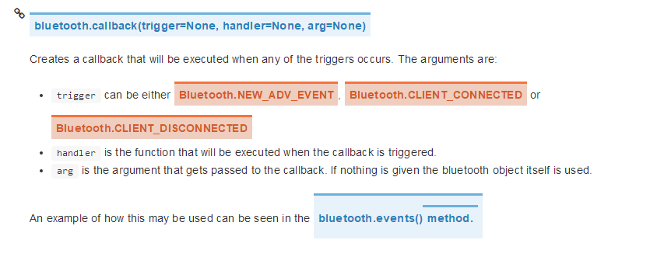

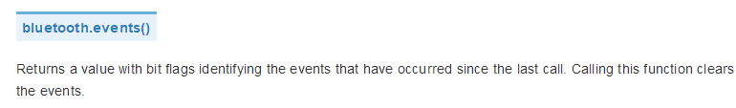

The basic idea of using the callback in server is straight forward:

* Bluetooth.events will return the big flags identifying those three events {Bluetooth.CLIENT_CONNECTED, Bluetooth.CLIENT_DISCONNECTED, Bluetooth.NEW_ADV_EVENT}

To DO list:

1) Check if a LoPy could act as Bluebooth server and client at the same time

2) Multiple thread application test

3) Test BLE and LoRa working at same time

### 5.3 Summer Week 6: 07-02~07-06

#### 07-02

##### 5.3.1 Multiple threads test

1) Test multiple thread running in the LoPy

Exception catch and exit thread

2) BLE and LoRa running in two different threads

These could work!

To do list:

1) When running BLE and LoRa at the same time, need to deal with a shared buffer that for these two protocol.

BLE has both W/R permission.

LoRa only can read.

2) Still need to deal with the client connect to one

#### 07-05

**1) Test GPS sensor in Pytrack, it works but something need to be considered first:**

* It need to be used outdoor, I tested in front of UAB, the result shows below:

The first two may failed? Need to consider the timeout before it could return the right coordinate

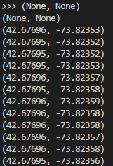

* If it works correctly, it will return a tuple of (lantitude,longitude) and this tuple can be used to locate cattle.
* For the cattle that don’t wear pytrack so just add (None,None) in the transferred data
* **Make a strategy that deals with the situation when GPS doesn’t work and it could still work as a normal node, and when GPS data recovers just add the data to LoRa package again.**

TO DO list:

1) BLE communication still has problem, I have mailed pycom and hope could get their response soon.

2) LoRa gateway testing which includes three parts:

* Test LoPy wifi connecting to a WiFi network
* Test LoPy to TTN cloud
* Test LoPy as LoRa node send data to LoPy gateway

### 5.4 Summer Week 7: 07-09~07-13

#### 07-09

##### 5.4.1 LoRaWAN start

Today start to test LoRaWAN to TTN server.

Follow the instruction from pycom documentation. Link below:

<https://docs.pycom.io/chapter/tutorials/lora/lorawan-nano-gateway.html>

The whole structure is:

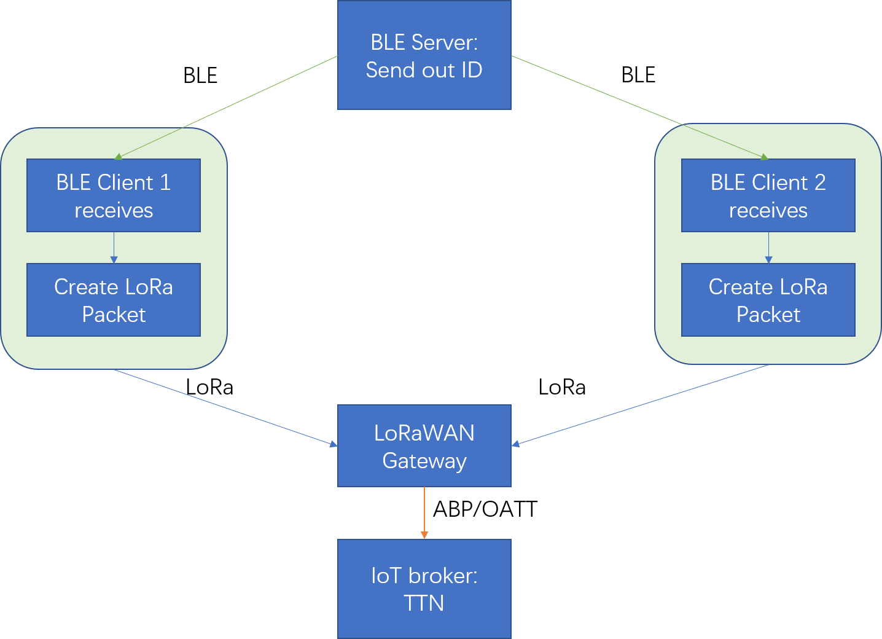

1 When set up the gateway in TTN, there is something need to notice:

1) Gateway ID:

Use the code bellow to get LoPy nano-gateway id:

from network import WLAN

import ubinascii

wl = WLAN()

ubinascii.hexlify(wl.mac())[:6] + 'FFFE' + ubinascii.hexlify(wl.mac())[6:]

2) Set the frequency to US 915 in config.py

3) The configuration could be done in TTN web page.

Right now the LoPy gateway could connected to TTN server:

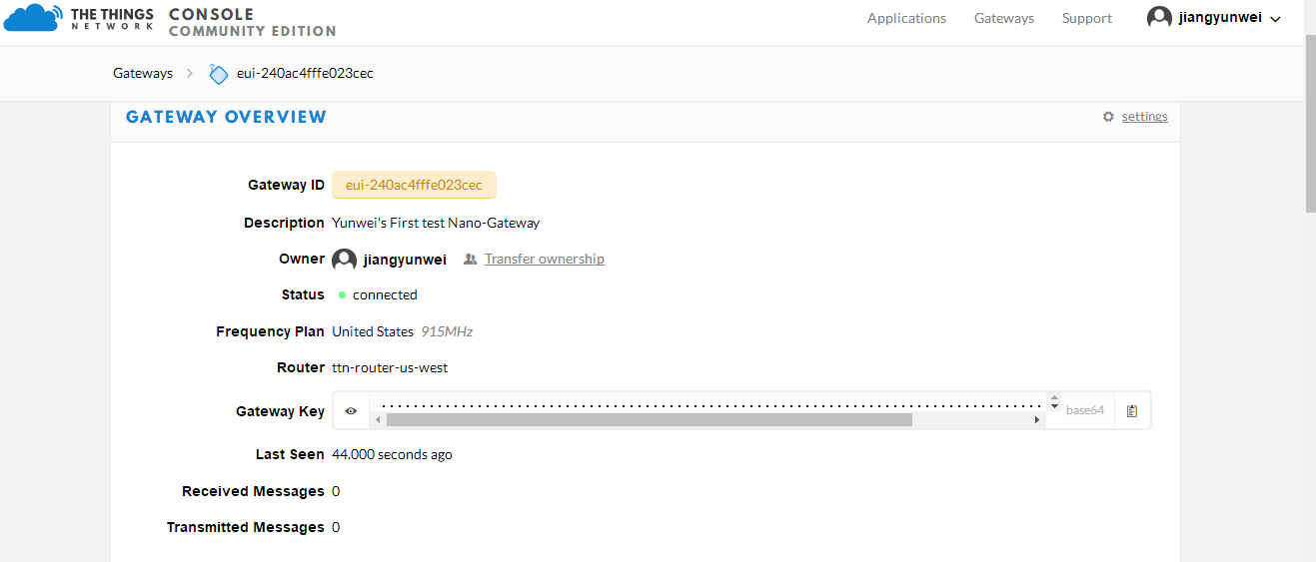

Figure 5.4.1.1 LoPy Gateway connected to TTN server

And the gateway also can push and pull acknowledge from server:

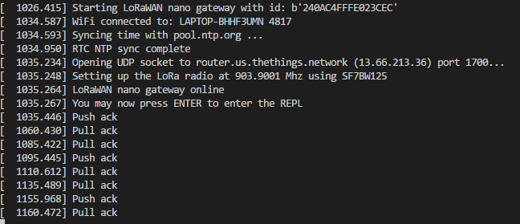

Figure 5.4.1.2 LoPy Gateway connected to TTN server

**Please notice that:** when modify the config.py file in gateway application, the TTN router for US need is

**router.us.thethings.network** !!! This part took me hours to solve!!!

The original question in forum:

https://forum.pycom.io/topic/2787/solved-lopy-connection-to-us-ttn/2



2 When set up LoRa node device in TTN, need to first set up an Application:

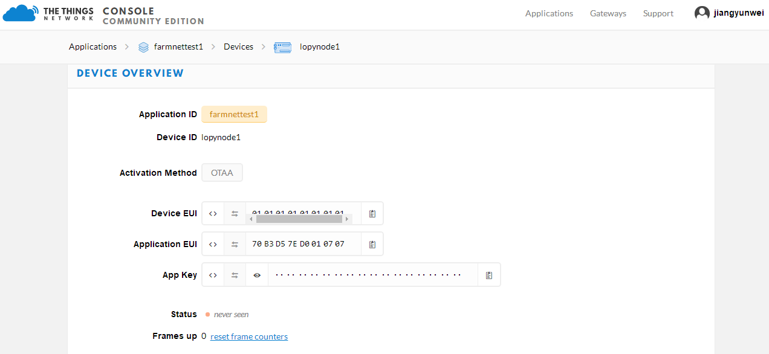

Notice: I have tried whole afternoon to connect one Lopy node to TTN server through a LoPy nano-gateway, OTAA can’t work, **but when change to ABP, the gateway can finally receive the data and push to server!!!** Still don’t know why, but this means the data could sent to server!

TO DO list:

1) Configure the server to analyze the package in application data. Right now just know the server could received data.

2) Find out why it could work in ABP mode

3) Set up three LoPys to send data to gateway.

4) Try to build up a protype network that receiving data by BLE and send to server by LoRa

#### 07-11

##### 5.4.2 LoRaWAN continue: TTN gateway and LoRa node test

**1 Latest Work progress**

Yesterday I still continued to test the TTN and LoRa node. There are some problems:

1) Although in the “traffic” tag of Gateway in TTN, I can see all the data that pushed by the nano-gateway, but in my application data tag, I can’t see any data from the node device… Have sent the email to Pycom, wait for their reply.

2) There are some details need to figure out:

* The range of default Blue tooth communication

Since Blue tooth need to be used as short range communication protocol for cattle social graph, the range can’t be very wide. But based on the previous reply from Pycom, the range can’t be changed right now by user. I have sent email asking about the default range today.

* The range of LoPy work as a LoRaWAN singl channel gateway

Also need to find out this, since LoRa is used as long range protocol for transferring the collected data from LoRa nodes to server.

* Data frequency

Need to ask professor.

2 LoRaWAN test: two nodes

I have added a gateway in TTN:

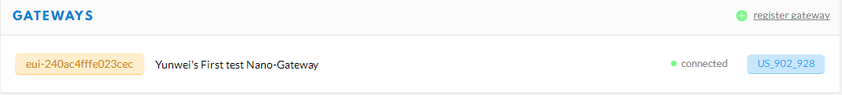

Then I use two Lopy as LoRa nodes that send packet, and the nano gateway pushes all of these uplink request to TTN, result shows below:

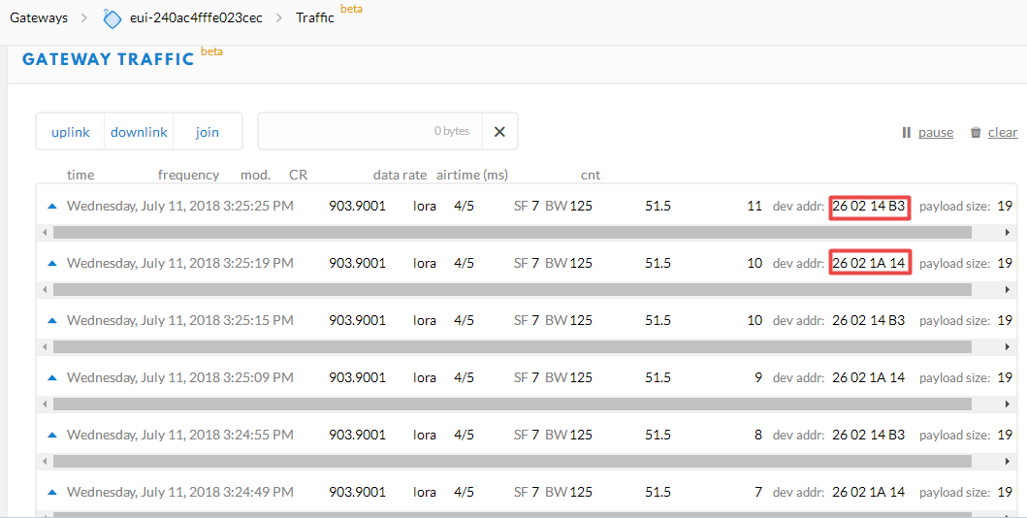

And the details of each data packet:

**Notice that it only can show payload as raw data, need to write the decode function in the “Application” console to analyze the raw data in right format. The data could be decoded in json format and then forwarded to the real server that need to store and manage these data.**

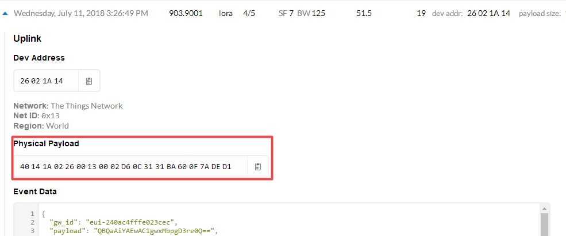

In my application, I add two LoPy as LoRa node devices:

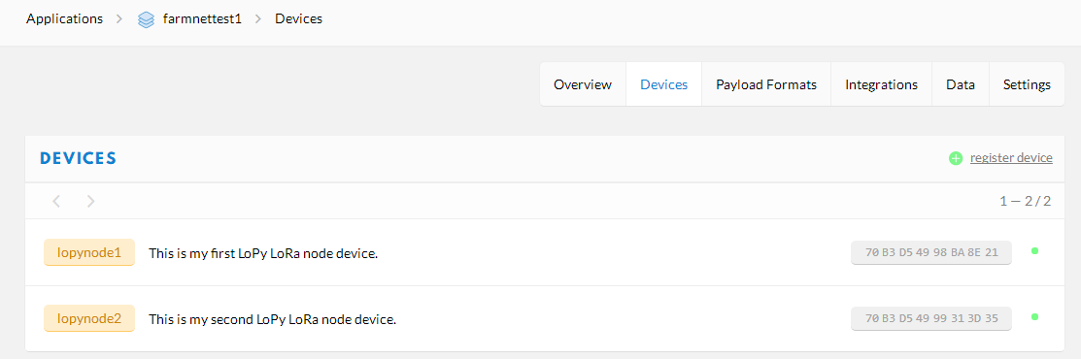

And the information of each device (the status of device is forwarded to this application and TTN can also check their connection status):

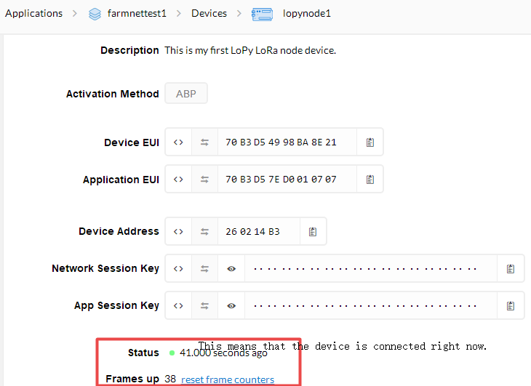

Fig Node1 is connected in

But! OTAA can’t work for LoPy nodes. ABP could work but the data won’t show in “application data” tag in TTN…

Waiting for Pycom reply.

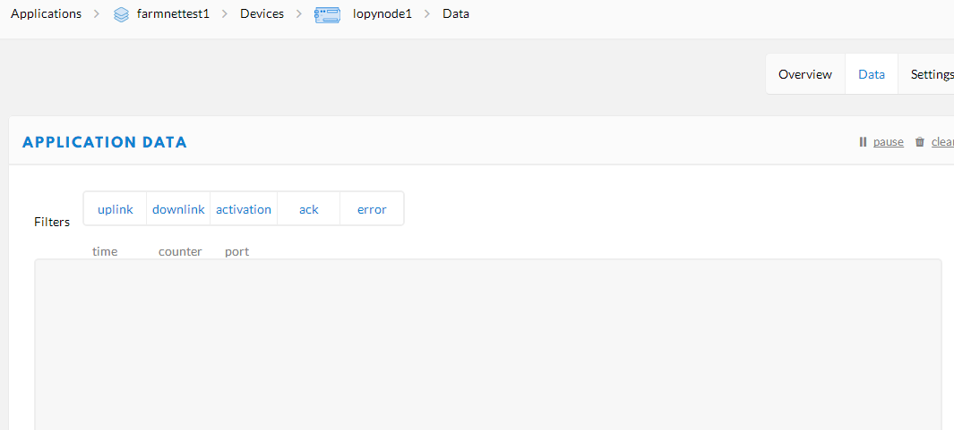

#### 07-12

##### 5.4.3 BLE test: one server and two clients

Today I finished another Blue tooth communication test.

One server to two clients.

The clients will connect and disconnect to the server alternately, and print out the data received from server.

The function and logic is ok, but one of the client(may be any one) will have an exception after repeating this action for around 125 times…

Just sent email to pycom and wait for reply.

#### 07-13

##### 5.4.4 BLE and LoRa node test

Use one LoPy as Blue tooth server, one as LoRaWAN gateway, one as blue tooth client and LoRa node.

This could work. The one as blue tooth client and LoRa node could received the data from server, and also send this data to LoRaWAN gateway.

So this means that the basic structure of the system:

1) BLE client connects and receives data(ID of other cattle) from server and create data packet

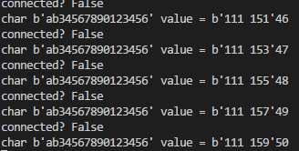

Fig BLE client print message

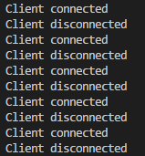

Fig BLE server print message

2) Send the packet by LoRa to LoRaWAN gateway, disconnect from this server, then scan for other servers

3) LoRaWAN gateway push packet to TTN

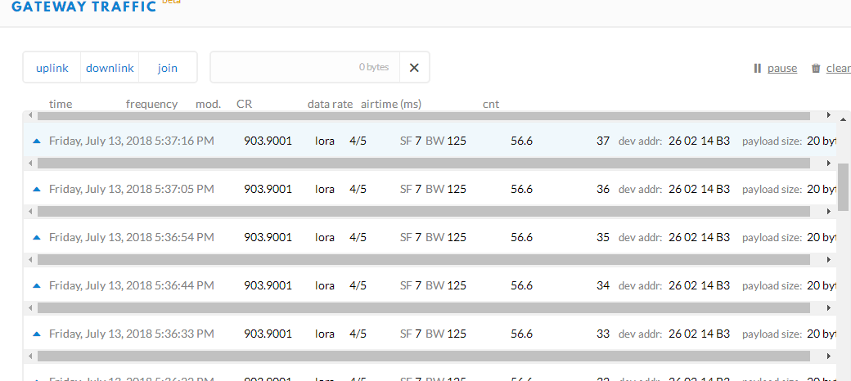

Fig TTN Gateway traffic

This structure could work as expected.

**But there are still some problems:**

1) BLE client crush after repeating connecting & disconnecting after around 120 times

2) ABP data from LoRa Node can’t show in TTN…

3) Data frequency for research

I have send email to pycom asking the first two questions.

The last question need to ask professor.

### 5.5 Summer Week 8: 07-16~07-20

#### 07-19

##### 5.5.1 Three LoPy BLE communication test

This test will be the protype test for BLE node communication for all of these node devices.

1) Each node works as BLE server and client

2) As server: they set up an advertisement and a service

#### 07-20

##### 5.5.2 LoRaWAN problems

Still has the problems:

1) LoPy maybe can’t work as GATT server and client at same time, even start both functions, but only one role could be set at one time?

**Or find a way to end the procedure when the client disconnected from server**

**2） LoRaWAN device**

**Still can’t see the device data in TTN**

But when I posted the question in TTN forum, someone answered that maybe the frequency of gateway and device is not the same? Don’t know yet… Since for node device, there is only one frequency set, and it’s the same to gateway.

TODO list:

1) LoRaWAN device

Maybe the channel need to be set?

* Reset the frame counter for ABP device
* Try to use channel 1(Start from 0) next week.
* Or in the ABP code sample:

**Read the documentation again!!!**

<https://docs.pycom.io/chapter/firmwareapi/pycom/network/lora.html>

**Set block and then unblock**

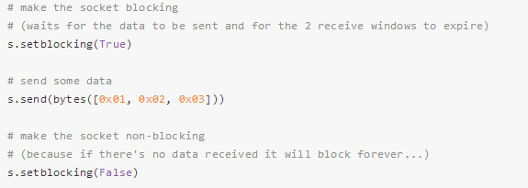

Adding the code below after create lora object:



Some other similar questions and solutions in TTN forum:

<https://www.thethingsnetwork.org/forum/t/datta-node-is-not-shown-in-console-but-meta-data-is-shown/6954/14>

2) If still can’t solve the problem, then change to LoRaMAC gateway to AWS

https://forum.pycom.io/topic/236/lopy-nano-gateway/38

### 5.6 Summer Week 9: 07-23~07-27

#### 07-24

##### 5.6.1 Another prototype structure: LoRa gateway+Adafruit IO

Since I still didn't get the reply from pycom company about 1) device data can't show in TTN and 2) LoPy can't run as BLE server and client at same time problems. So I change the structure to another way:

**1) Use LoRa gateway(plain lora) configuration instead of LoRaWAN gateway**

LoRaWAN is designed to share and support different LoRa nodes device connecting to the open gateway around, and forward the data to IoT broker as TTN,Loriot. Since we only need to build up a private LoRa network, so a simple LoRa nano-gateway could do the work.

**2) Using MQTT to connect to another IoT platform as AWS, AdafruitIO, etc**

I have tried to use the AdafruitIO platform to obtain and manage the data forwarded by gateway

So right now the structure is like below:

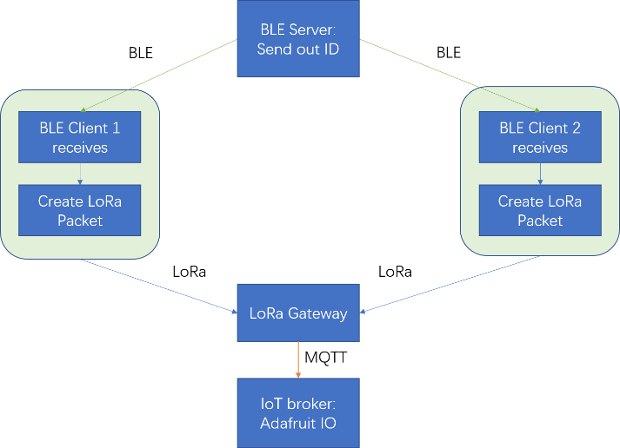

**There are some screen shots below:**

**1 The result from Adafruit IO:**

Ignore the name lights...

The message stream show the data that sent by gateway:

Means one LoPy get the ID from other server and send to gateway.

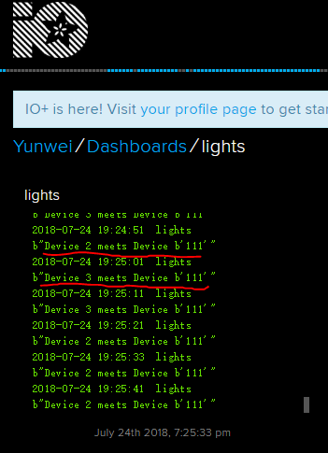

The data can be download as json or csv format:

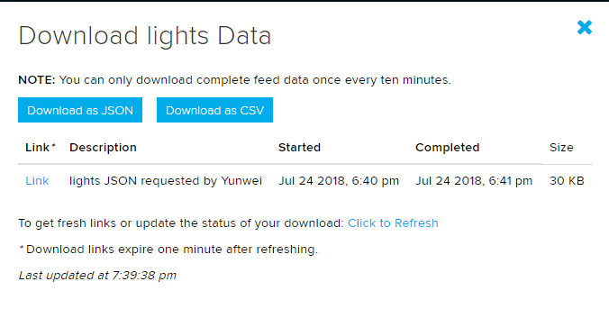

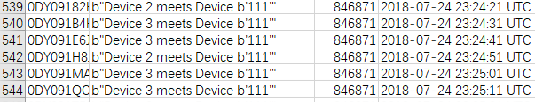

**2 Gateway print out message:**

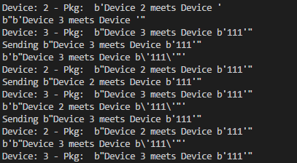  
**3 BLE server:**

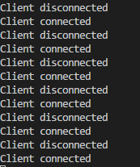  
**4 BLE client + LoRa node:**

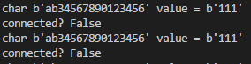

So in this way, the problem can also be solved.

## 6 Helpful information

### 6.1 About LoRaWAN gateway configuration

<https://docs.pycom.io/chapter/tutorials/lora/lorawan-nano-gateway.html>

#### 6.1.1 How to get gateway id?

Using the code below in console:

from network import WLAN

import ubinascii

wl = WLAN()

ubinascii.hexlify(wl.mac())[:6] + 'FFFE' + ubinascii.hexlify(wl.mac())[6:]

#### 6.1.2 How to get device EUI?

from network import LoRa

import ubinascii

lora = LoRa()

print("DevEUI: %s" % (ubinascii.hexlify(lora.mac()).decode('ascii')))

#### 6.1.3 Pycom GitHub link

<https://github.com/pycom/pycom-libraries>

### 6.2 LoPy helpful instructions

#### 6.2.1 OS and firmware information



### 6.3 About LoRaWAN

#### 6.3.1 LoRaWAN overview

**The contents are from** <https://www.thethingsnetwork.org/docs/lorawan/>

LoRaWAN is a media access control (MAC) protocol for wide area networks. It is designed to allow low-powered devices to communicate with Internet-connected applications over long range wireless connections. LoRaWAN can be mapped to the second and third layer of the OSI model. It is implemented on top of LoRa or FSK modulation in industrial, scientific and medical (ISM) radio bands. The LoRaWAN protocols are defined by the LoRa Alliance and formalized in the LoRaWAN Specification which can be requested on the LoRa Alliance website.

##### 6.3.1.1 Terminology

* [**End Device, Node, Mote**](https://www.thethingsnetwork.org/docs/devices/) - an object with an embedded low-power communication device.
* [**Gateway**](https://www.thethingsnetwork.org/docs/gateways/) - antennas that receive broadcasts from End Devices and send data back to End Devices.
* [**Network Server**](https://www.thethingsnetwork.org/docs/network/) - servers that route messages from End Devices to the right Application, and back.
* **Application** - a piece of software, running on a server.
* **Uplink Message** - a message from a Device to an Application.
* **Downlink Message** - a message from an Application to a Device.

**Note: In this project, use Lopy as either node or gateway.**

##### 6.3.1.2 End Devices

The LoRaWAN specification defines three device types. All LoRaWAN devices must implement Class A, whereas Class B and Class C are extensions to the specification of Class A devices.

**Class A devices** support bi-directional communication between a device and a gateway. Uplink messages (from the device to the server) can be sent at any time (randomly). The device then opens two receive windows at specified times (1s and 2s) after an uplink transmission. If the server does not respond in either of these receive windows (situation 1 in the figure), the next opportunity will be after the next uplink transmission from the device. The server can respond either in the first receive window, or in the second receive window, but should not use both windows.

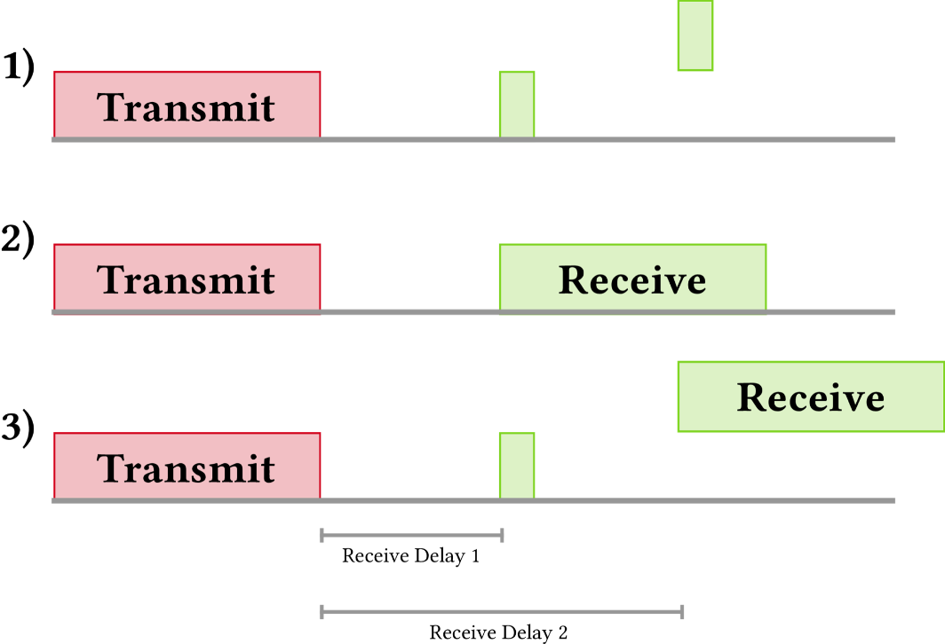

Fig LoRaWAN Class A device

**Note: When LoPy as device, it’s Class A device.**

**Class B** devices extend Class A by adding scheduled receive windows for downlink messages from the server. Using time-synchronized beacons transmitted by the gateway, the devices periodically open receive windows.

**Class C** devices extend Class A by keeping the receive windows open unless they are transmitting, as shown in the figure below. This allows for low-latency communication but is many times more energy consuming than Class A devices.

##### 6.3.1.3 Frequency and Bands

**US 902-928 MHz**

In the United States, LoRaWAN operates in the 902-928 MHz frequency band. Unlike the European band, the US band has dedicated uplink and downlink channels. The band is divided into 8 sub-bands that each have 8x125 kHz uplink channels, 1x500 kHz uplink channel and 1x500 kHz downlink channel. **The Things Network uses the second sub-band (number 1 if you start counting at 0).**

**In the US902-928 bands the data rates are as follows:**

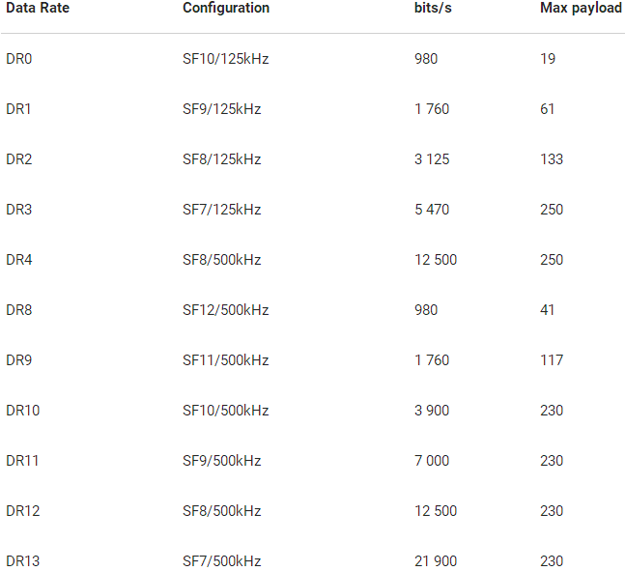

### 6.4 LoRaWAN Data Rate Limitations

The data message for each node device has the limitations in LoRaWAN, there is the topic that in TTN forum:

<https://www.thethingsnetwork.org/forum/t/limitations-data-rate-packet-size-30-seconds-uplink-and-10-messages-downlink-per-day-fair-access-policy/1300/42>

##### 6.4.1 Uplink limitation policy

<https://www.thethingsnetwork.org/forum/t/universal-lora-wan-gateway-limitations-because-physics/1749/8>